Google Cloud Platform

Project Website with Class Roster

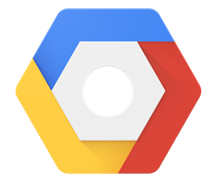

A Source Manual By:

Nathan Guenther & Zach Colby

As a Part of CIS 4932C: Cloud Computing Concepts

4/19/2016

**Setup Procedure**

Note:* Commands are via gcloud command line tool

Prep

* Install the gcloud and kubectl command line interfaces.

Create Container Engine Cluster

* gcloud container clusters create wppd --num-nodes 2

Create Persistant Disks

* gcloud compute disks create --size 200GB mysql-disk
* gcloud compute disks create --size 200GB wordpress-disk

Set up mysql.yaml with unique configurations

* Configure database password

Create mySql Kubernetes Pod

* kubectl create -f mysql.yaml // Build pod from config
* kubectl get pod mysql // Confirm It’s Running

Create mySQL service to direct pods to database

Set up mysql-service.yaml with unique configurations

* Configure database port & label

kubectl create -f mysql-service.yaml